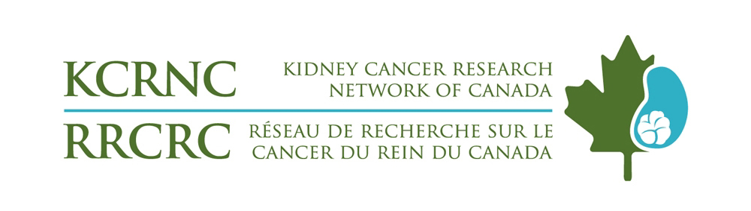

KCRNC/RRCRC 2025

CALL FOR ABSTRACTS
14th Canadian Kidney Cancer Forum
February 27th- March 1st, 2025
Toronto, Ontario

General Information
The Canadian Kidney Cancer Forum (CKCF) 2025 will take place at the Sheraton Airport Hotel on February 27th – March 1st, 2025. At this year’s forum, we are bringing back abstract presentations related to clinical or basic science research in kidney cancer.

Rating and selection of the abstracts for presentation will be based on scientific merit as determined by the members of the KCRNC/RRCRC Forum Planning Committee.

Key Dates:
Abstract Submission Opens: Nov 4th, 2024
Abstract Submission Deadline: Dec 20th, 2024
Abstract Notification sent to First Author: Jan 15th, 2025
Change/Withdraw Deadline: Feb 10th, 2025

Forum 2025: Feb 27th – March 1st, 2025

ABSTRACT SUBMISSION GUIDELINES

Abstracts must be submitted by email to: Adesola Leslie, KCRNC/RRCRC Program Coordinator: AdesolaOmowunmi.leslie@uhn.ca

Abstract submission deadline: Dec 20, 2024. You will receive a confirmation of receipt within 5 working days.

- Call for Abstracts:
  - Summaries of new, ongoing and updated research will be acceptable for submission and presentation at either a moderated or unmoderated poster session. This includes both clinical and basic science research related to kidney cancer.
  - Word limit: 350 words

- Submission Policies and Criteria:
- Prior Publication: To qualify for acceptance, the content and conclusions of the abstract must not have been presented at any prior CKCF.
- First Author Disclosure: Author disclosures for all authors must be declared at the time of the abstract submission.
- Abstract Change Deadline: First authors may request corrections to rectify any errors within the abstract by emailing AdesolaOmowunmi.leslie@uhn.ca
- Abstract Withdraw Deadline: If the first author chooses to withdraw the abstract for any reason, a request must be submitted by February 10, 2025.

- Responsibilities of the First Author
- Agreement to attend and present the abstract if it is selected for presentation at the Forum.

- Instructions for Abstract Submission
- Organize the abstract according to the following headers: Background, Methods, Results and Conclusions.
- Describe the objectives and results of the research so that the Steering Committee can adequately evaluate the abstract.
- One data table may be included with the abstract.

- Correspondence
- The First Author/Presenter will receive an e-mail acknowledging receipt of the abstract after completing a submission. The First Author/Presenter will receive a letter of notification from the Steering Committee regarding its decision by February 14th, 2024. All communication will be with the first author only.

- Travel Awards
- First Authors/Presenters who are trainees, may be eligible to receive funding for registration and/or travel to the Forum to present the work. Specifics of the travel funding will be sent to the First Author/Presenter at the time of notification.

- Prizes
- Prizes will be awarded to the 1st ($400), and 2nd ($200) best posters in each category (clinical research and basic science).

- Inquiries
- Address all inquiries to: Adesola Leslie, KCRNC/RRCRC Program Coordinator: AdesolaOmownmi.leslie@uhn.ca

